Lab 05

# TASK 01

#define _CRT_SECURE_NO_WARNINGS

#include <stdlib.h>

#include <stdio.h>

#define MAX_STRING_LENGTH 80

int main()

{

// declaring variables

int age;

int height;

float weight;

int inches;

// Printing HOW OLD ARE YOU

printf("How old are you?\n");

scanf("%d", &age);

// printing HOW MANY FEET TALL ARE YOU

printf("How many feet tall are you?\n");

scanf("%d", &height);

// printing HOW MANY INCHES

printf("How many inches?\n");

scanf("%d", &inches);

// PRINTING HOW MUCH DO YOU WEIGH

printf("How much do you weigh?\n");

scanf("%f", &weight);

// Printing the complete info given by user

printf("So you're %d old, %d'%d tall and %.1f heavy.\n", age, height, inches, weight);

return 0;

}

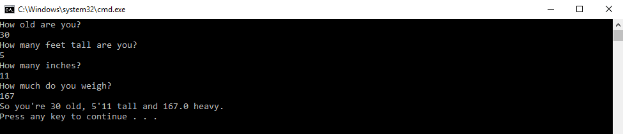

# Task 02:

#include <stdio.h>

#include <stdlib.h>

int main()

{

// declaring variables

char name[20];

int age;

float salary;

// PRINTING HELLO. WHAT IS YOUR NAME.

printf("Hello. What is your name? ");

scanf_s("%19s", &name, 19);

// PRINTING HI, (NAME) HOW OLD ARE YOU?

printf("Hi, %s! How old are you? ", name);

scanf_s("%19d", &age, 19);

// PRINTING HOW MUCH DO U MAKE

printf("How much do you make, %s? ", name);

scanf_s("%19f", &salary, 19);

// PRINTING THE SALARY

printf("%.1f! I hope that's per hour and not per year! \n", salary);

return 0;

}

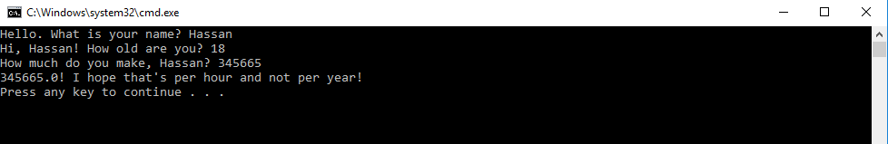

# Task 03:

#include <stdio.h>

#include <stdlib.h>

int main()

{

// declaring variables

char FirstName[10];

char LastName[10];

int semester;

int StudentId;

char LoginID[20];

float gpa;

// asking for basic info

printf("First name: ");

scanf_s("%9s", &FirstName, 9);

printf("Last Name: ");

scanf_s("%9s", &LastName, 9);

printf("Semester: ");

scanf_s("%d", &semester);

printf("Student ID: ");

scanf_s("%d", &StudentId);

printf("Login ID: ");

scanf_s("%19s", &LoginID, 19);

printf("GPA (0.0-4.0): ");

scanf_s("%f", &gpa);

// printing that info

printf("Your Information: \n");

printf(" Login: %s \n", LoginID);

printf(" ID: %d\n", StudentId);

printf(" Name: %s, %s\n", LastName, FirstName);

printf(" GPA: %f\n", gpa);

printf(" Semester: %d\n", semester);

return 0;

}

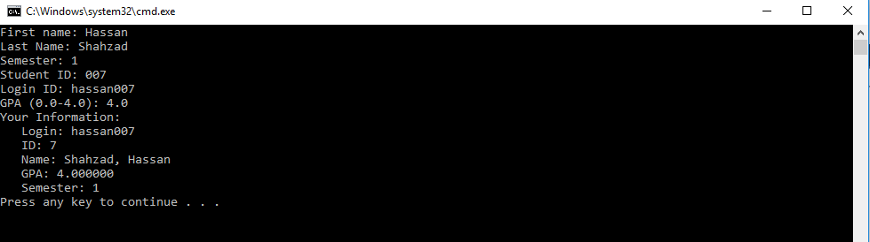

# Task 04:

#include <stdio.h>

#include <stdlib.h>

int main()

{

char name[20];

int age;

// asking for basic info

printf("Enter your Name: ");

scanf_s("%19s", &name, 19);

printf(" Hi, %s! How old are you? ", name);

scanf_s("%d", &age);

// telling about the user’s height before and after 5 years

printf("In five years you will be %d years old.", age+5);

printf("And five years ago you were %d years old\n", age-5);

return 0;

}

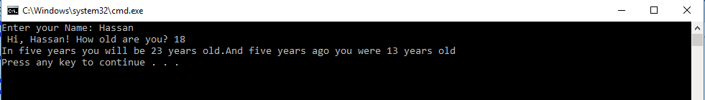

# Task 05:

#include <stdio.h>

#include <math.h>

int main()

{

// declaring variables

float a;

float b;

float c;

float answer;

// asking for basic info

printf("What is your first number? ");

scanf_s("%f", &a);

printf("What is your second number? ");

scanf_s("%f", &b);

printf("What is your third name? ");

scanf_s("%f", &c);

answer = (a + b + c) / 2;

// displaying answer

printf(" ( %.1f + %.1f + %.1f ) / 2 is …. %.1f\n", a, b, c, answer);

return 0;

}

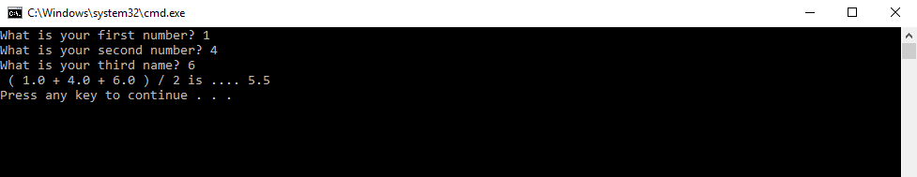

# Task 06:

#include <stdio.h>

#include <stdlib.h>

int main()

{

// declaring variables

float height;

float weight;

float BMI;

printf("Your height in m: ");

scanf_s("%f", &height);

printf("Your weight in kg: ");

scanf_s("%f", &weight);

// calculating bmi

BMI = weight / (height * height);

printf("Your BMI is: %f\n", BMI);

return 0;

}

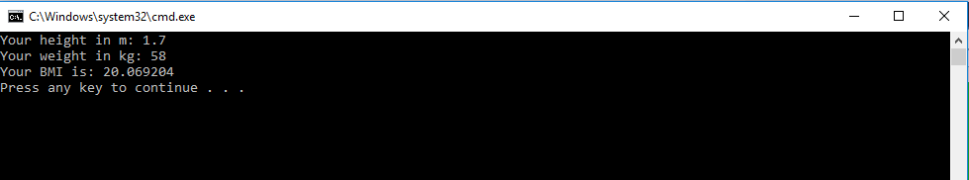

The End